|  |  |  |  |  |
| --- | --- | --- | --- | --- |
| logoSaoJOSE.wmf | **FUNDAÇÃO EDUCACIONAL CLAUDINO FRANCIO** **CENTRO DE EDUCAÇÃO BÁSICA SÃO JOSÉ** | | | |
| Disciplina: Inglês | Professora: Abielly / Luciana | | Data: ___/___/ 2020 |
| Aluno (a): ________________________________ - 4º Anos | | | Review | |

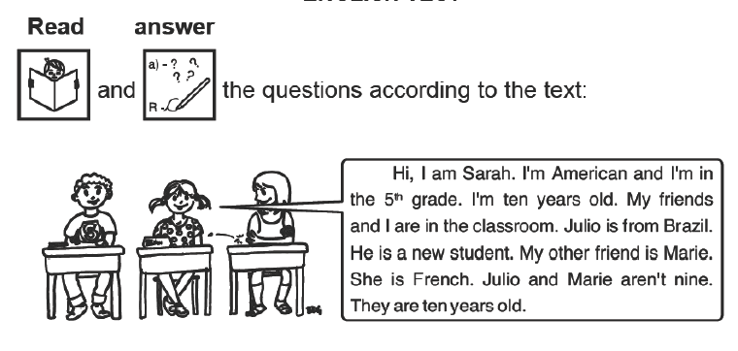

1. How old is Sarah?

_________________________________________________

1. What are the names of Sarah friends?

_________________________________________________

1. Is Marie from French? _________________________________________________
2. Where is Sarah from?

_________________________________________________

1. Where are they?

_________________________________________________

1. Is Julio nine years old?

_________________________________________________

