|  |  |  |  |  |
| --- | --- | --- | --- | --- |
| logoSaoJOSE.wmf | **FUNDAÇÃO EDUCACIONAL CLAUDINO FRANCIO** **CENTRO DE EDUCAÇÃO BÁSICA SÃO JOSÉ** | | | |
| Disciplina: Inglês | Professor: Abielly - Luciana | | Data: ___/___/ 2020 |
| Aluno (a): _________________________________ - 2º ano | | | Extra Activities - Lesson 1 | |

***Review Exercises***

1. Vamos Traduzir as ***Greetings*** abaixo:

GOOD MORNING: _____________________________________________________________

GOOD AFTERNOON: __________________________________________________________

GOOD NIGHT: ________________________________________________________________

HELLO: _____________________________________________________________________

GOOD BYE: _________________________________________________________________

2. Complete:

I AM _______________________________________________________________________

I AM __________________ YEARS OLD.

3. Pinte das ***Colors*** corretas:

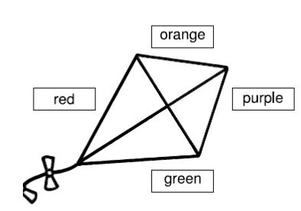

Good Luck!!!